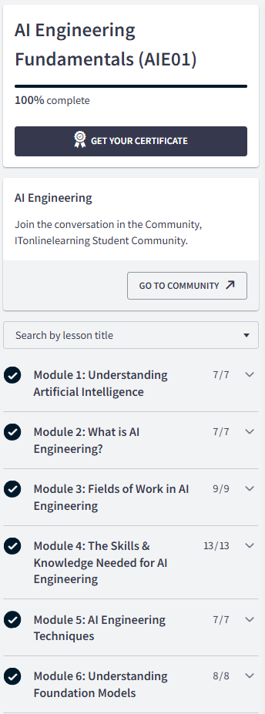

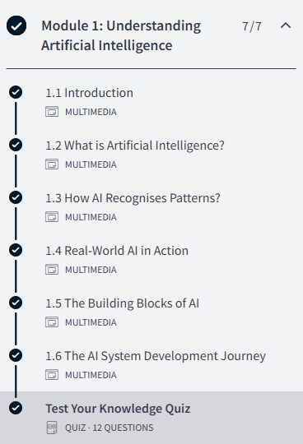
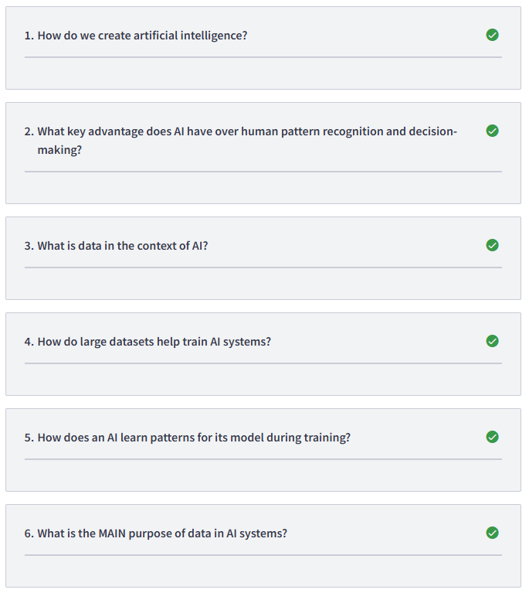
1/ By teaching computers to recognise patterns and produce smart outputs
2/ AI operates at a scale and speed humans could never achieve on their own
3/ Digital information used by computer programs
4/ They allow the AI to recognise patterns for its objectives
5/ Clever systems use mathematics to identify patterns in the data
6/ AI needs data to learn patterns during training and apply those patterns to new inputs

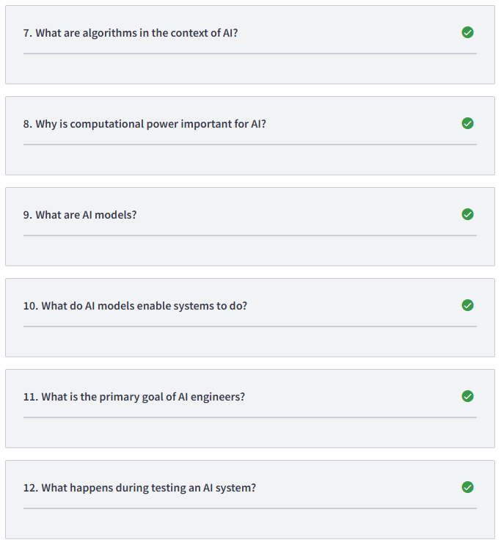
7/ Step-by-step computational procedures that define how AI processes data and makes decisions
8/ It enables AI to work at the scale and speed required for effective operation
9/ Trained mathematical structures that represent learned patterns and knowledge from data manipulated and used in practical AI systems
10/ Make predictions, carry out classification tasks, and generate different outputs
11/ To adapt and deploy AI models into systems for practical use
12/ The AI system is evaluated to ensure it works correctly before deployment

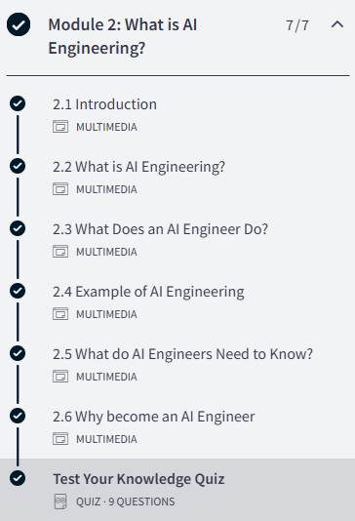
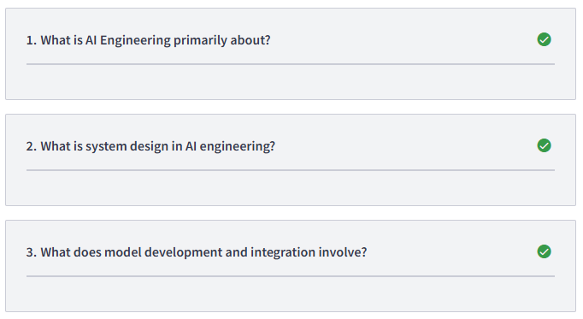
1/ Turning AI research into practical scalable solutions
2/ Defining the structure, components, and data flow of the system that will use the AI model
3/ Creating, training, and deploying AI models

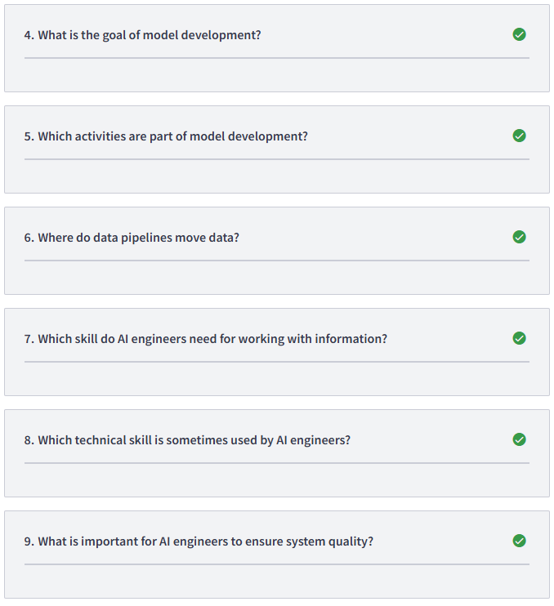
4/ To solve specific problems
5/ Creating the model, Training the model, Deploying the model
6/ From source systems to destination endpoints
7/ Data skills
8/ Machine learning
9/ Test systems with AI

